POE Part 3

Name | Sujendran Reddy
Student Number | 10457761
Module | PROG6212
Lecturer | Dharshanee Moodley
Date of Submission | 21/11/2025
I hereby declare that I did not plagiarise the content of this assignment and that this is my own work. I also declare that no use of GenAI was used in the creation of this submission (unless explicitly permitted and declared), excluding grammar and spell checkers. I consent to the lecturer assessing our work using an AI detection tool to ensure the integrity of our work.
Assignment submitted via SafeAssign: ☒ (Tick the Box

Table of Contents
Lecturer Feedback. 3
Links. 4

Lecturer Feedback.
Feedback:
The design of the view is highly intuitive and well-structured, enhancing the verification process significantly. Managers should only see claims that have been verified.
Response:
Managers can now only see verified claims instead of claims that have yet to be verified or rejected.
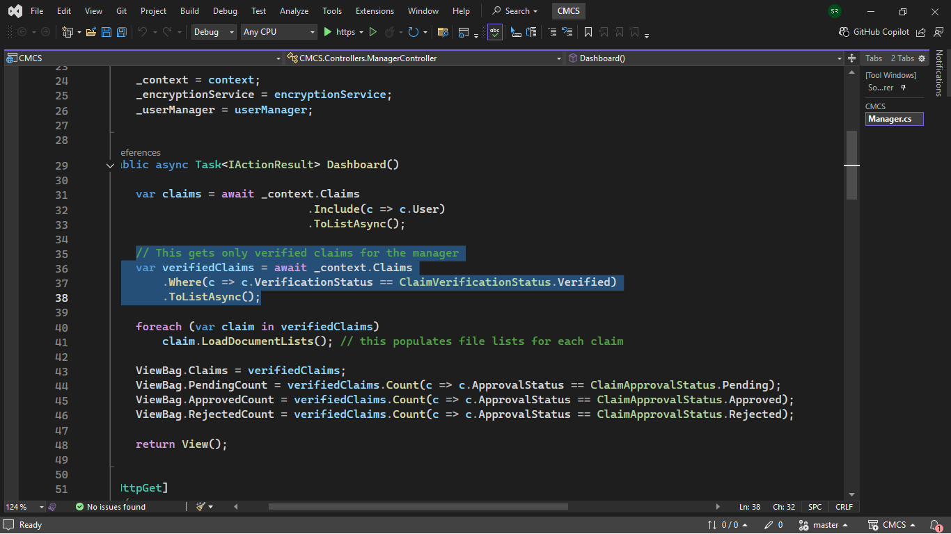

Links.
Youtube:
https://youtu.be/HuchyKBISBM?si=4YvqhdnukYkPYpXf
Github:
https://github.com/IIEVCPMB/prog6212-poe-part-1-SujendranReddy

